Ryan Harty

Decision Analysis

12/2/19

Merck and Company: Product KL-798

Our client is Pat Harlow, Chief Licensing Officer for Merck and Company. Recently, he has been approached by Kappa Labs with the prospects of acquiring a new drug, KL-798. If successful, this drug aid in the treatment of obesity and cholesterol. Kappa Labs is offering to sell this developmental drug to Merck for the upfront cost of $30 million and royalties payments that span the first ten years of the products life. Currently, KL-798 is only half way through Phase 1 trials. Even though the drug is in early stages of development, it has attracted a considerable amount of attention. If the drug is approved by the FDA and can be used to treat both obesity and cholesterol, it will have a market value of $510 million, if it is only approved for obesity it will have a market value of $430 million and if it can only treat cholesterol it will have a market value of $50 million. While this drugs seems promising, there are risks associated with present value of the drug due to the three stages of FDA approval it needs to go through first.

After building a decision tree, it is in Pat Harlow’s and Merck & Company’s best interest to not buy the rights to the drug. If they were to buy the rights to the drug, it would have an expected value worth -$1.16 million. For this analysis I built a decision tree with the option to pursue the drug or not pursue the drug at each phase and set it to a chance node with a 100% probability of pursuing the drug, to mimic the conditions if the option to not produce the drug given a phase were not available. The most valuable phase three outcome was if the drug were only approved for obesity in phase 2, in which case the value of the drug would be $197.5 million. If it made it past phase 2 for only cholesterol, the expected value would be -$90. And, if the drug made it past phase 2 for both conditions, the expected value would be worth $160.5 million. However, there is high risk for failure along the way and the overall expected value of the drug is negative, so Pat Harlow and Merck & Company should not buy the rights.

When examining the option to either continue or not go forward with the clinical testing of the drug at each stage, the expected value was -$260,000. To account for the option I took the chance nodes I created in question 1, that mimicked no option, and turned them into decision nodes. The only option to not continue R&D of the drug would be when the drug was only approved for cholesterol in phase 2. Under this option to not continue development, Merck & Company would lose $70 million on the venture, opposed to the expected value of -$90 million it would have incurred if they did not have the option. Even given this option, Pat Harlow and Merck & Company should not buy the rights to the drug due to the negative expected value of the company.

The first sensitivity analysis I performed was on the probability of phase 1 trial succeeding. If probability increased to 61% the expected value of the drug would be worth $319,000 dollars, which is an increase of almost $500,000 compared to a 60% probability. Next, I looked at the sensitivity for phase three where phase 2 was a success for obesity and cholesterol. Under this assumption, if the success for both drugs in phase 3 went from 60% to 61%, the expected value of the project would increase to $658,000. Also, under the past assumptions of phase 2 succeeding for obesity and cholesterol, if the probability of success for obesity only being approved went from 15% to 16%, the value of the project would be worth $514,000.

To account for perfect information, I change the phase 1 decision node with a chance node. If Foresight Consulting could in fact predict the outcomes of phase 1 trials, the expected value of the drug would be $31.74 million. The value of this perfect information would be worth $31.74M - $216,000 = $32M.

Without option to continue (Chance node set to 100% instead of decision node)

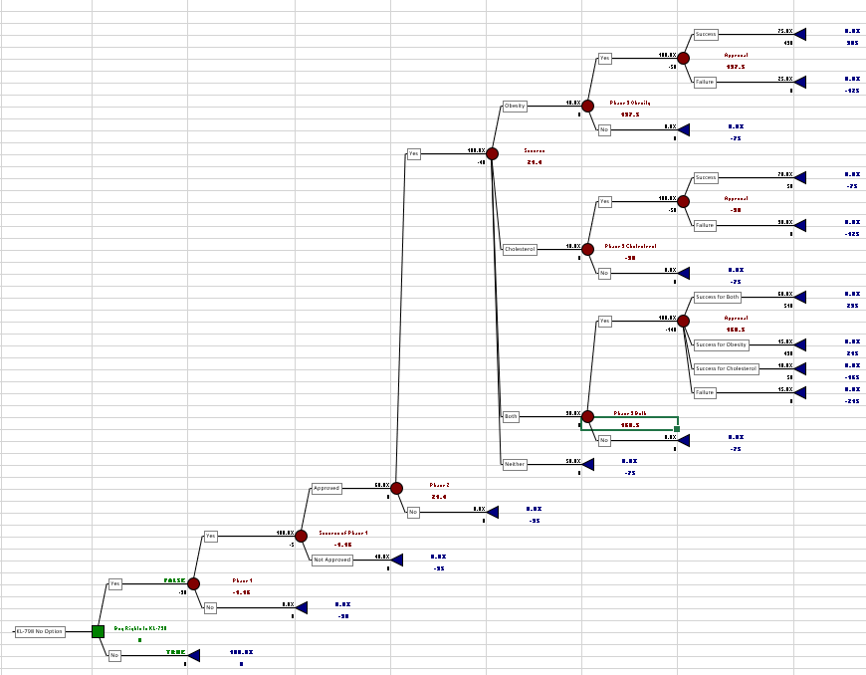

With the option to not continue

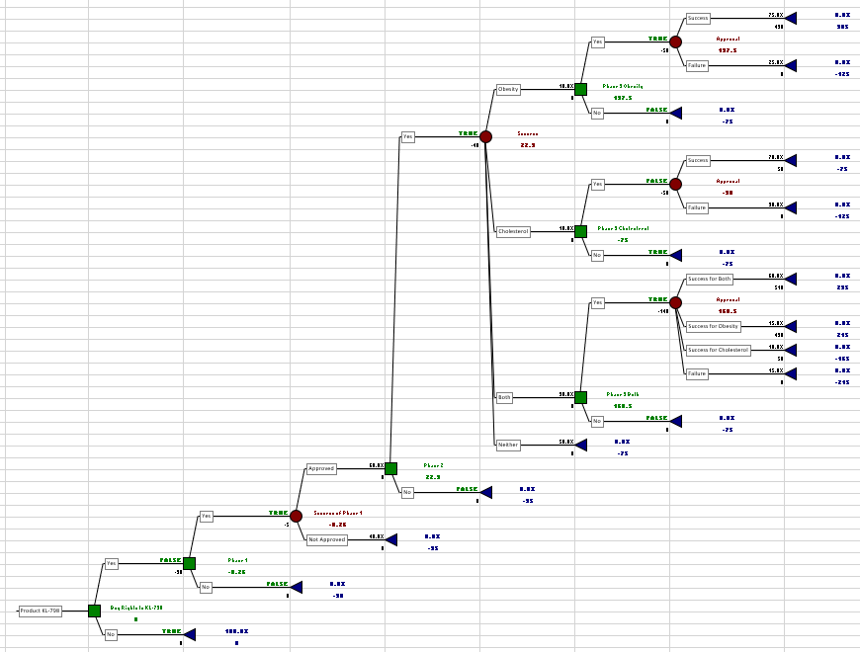

Value of Perfect Information

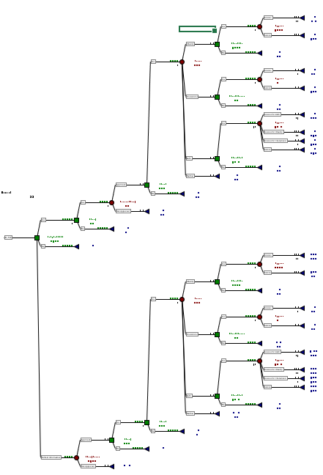

Value of Perfect Information

